HOW TO: Printer Calibration | Version: 1.0.0
Printer Name: Zebra | Printer Model: TLP2844
Author: Yamija Munthali | Date Issued: 2 November, 2017

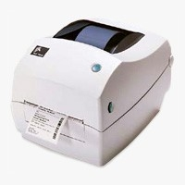

Step 1:
Make sure the printer is off  (If the printer is on please turn it off) | 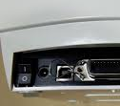  Power  Button
Step 2:
Press and hold the spooler button | Spooler  Button
Step 3:
Without releasing the spooler button Switch on the printer, wait until the light around the spooler button flashes three times, then release the spooler button | The printer will start printing, wait until it finishes printing.
Step 4:
Press the spooler button once to exit the dump mode | The printer will print out of dump signaling the end calibration

